23.61: a) From Problem 23.57,
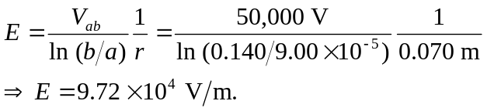
b) 